  2021 Schedule
  14-Jun 10:00
  GETTSBURG NATIONAL
  15-Jun 8:00
  CALEDONIA GC
  22-Jun 12:00
  BLACK ROCK GC
  23-Jun 10:00
  CARROLL VALLEY GC
  5-July 8:00
  CHAMBERSBURG CC
  6-July 11:30
  PENN NATIONAL GC
  12-July 8:00
  WAYNESBORO CC
  13-July 9:30
  GREENSCASTLE GC
  21-July 8:30
  EAGLE CROSSING GC
  22-July 11:30
  CHAMPIONSHIP
  PENN NATIONAL GC
  *9 hole tournaments for 12 and under boys and 13 and under girls.
  ** 13 and older boys and 14 and older girls only.
  Frank Wells
  226 HARMONY DR
  JOHNSTOWN PA 15909
  Franklin County Junior Golf Tour
  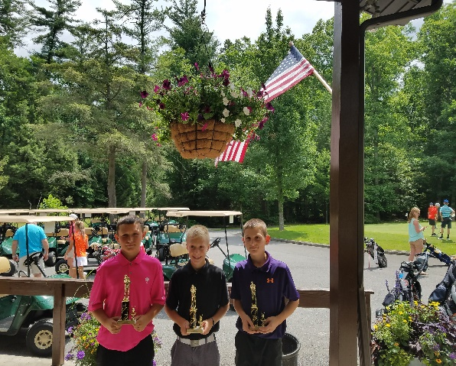
  The goal of the Franklin County Junior Golf Tour is to provide a venue where young people can enjoy all that competitive golf has to offer.
  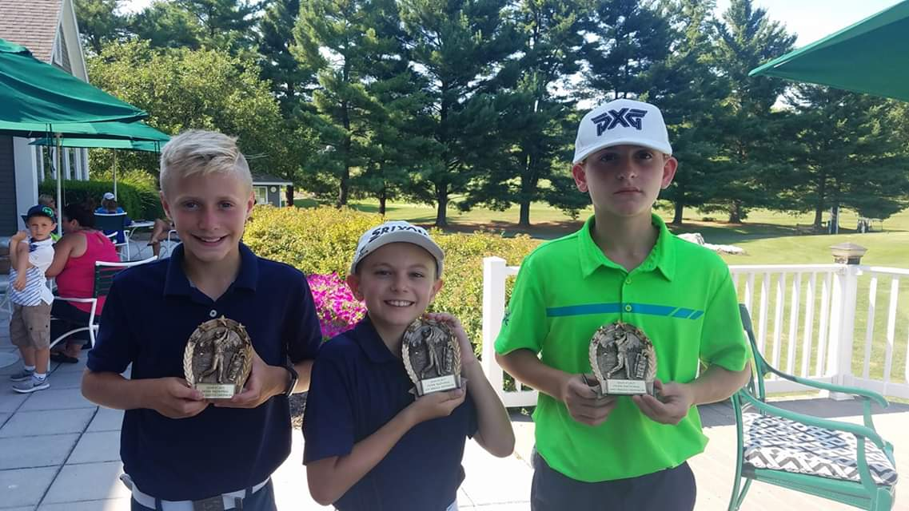

 | Hold Harmless Agreement  We understand The Franklin County Junior Golf Tour, its Director, employees, volunteers, golf course owners, or employees cannot be held liable for any damage or injuries suffered while participating in or traveling to or from a Franklin County Junior Golf Tour event. We also agree to abide by all rules and policies set forth by the Franklin County Junior Golf Tour.  Signature of Member  _________________________________________________  Signature of Parent/Guardian |  |  |  | 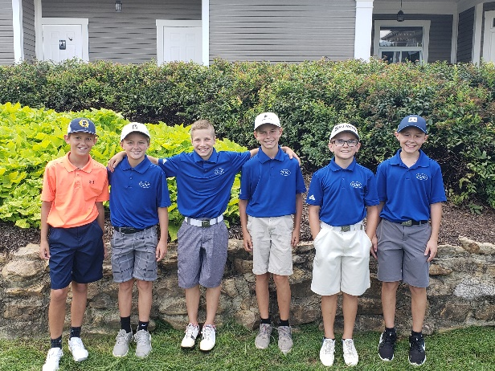  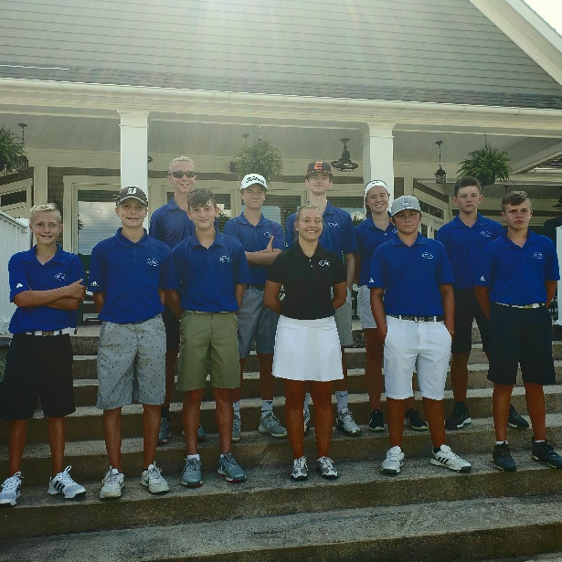  Contact Us  226 HARMONY DR  JOHNSTOWN PA 15909  717-729-7480  FCJGT11@gmail.com  Facebook: Franklin County Junior Golf Association
  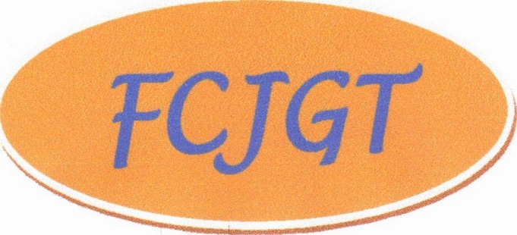
  Tour Membership Application
  Name__________________________________
  Address_________________________________
  _________________________________________
  Sex_______ Age as of 6/1/2021_________
  E Mail___________________________________
  Health Issues__________________________________
  Cell phone (_____)________________________
  Parent/Guardian Name__________________________________
  Shirt size________________________
  Membership Fees
  Annual membership fee per member - $140.00 due with application. Boys 12 and under and girls 13 and under $90.00 for 9 holes. . Please make checks out to Frank Wells/FCJGT. Membership fee includes tournaments, bag tag, trophies.

